**Nama : Devika Silpiana**

**Kelas : IF D**

**NIM : 1127050036**

Activity diagram vanding machine :

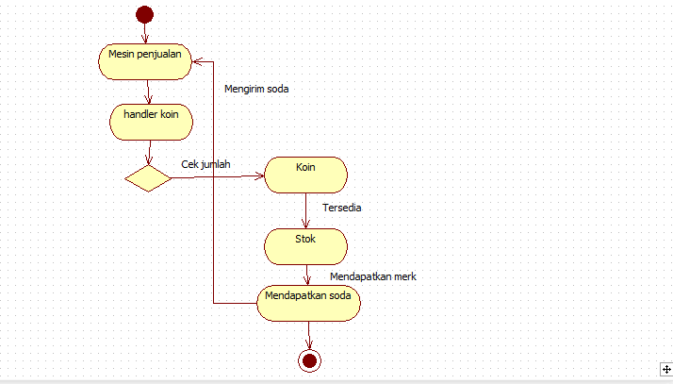

State diagram vending machine :

